SEA CLOUD SPIRIT WELCOMES SOUTH FLORIDA CULINARY AND LITERARY ICONS ON 2024 SAILINGS:
CHEF CINDY HUTSON AND AUTHOR LES STANDIFORD

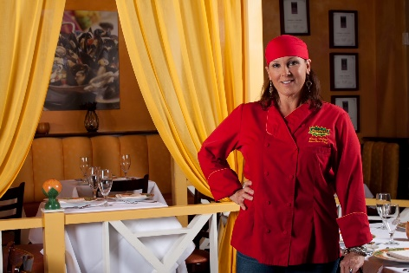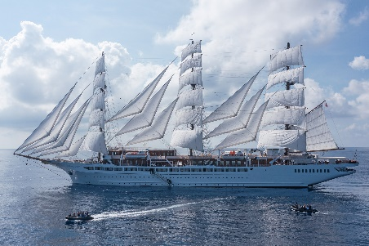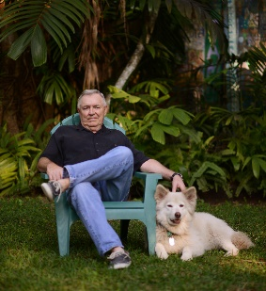

Media Images Link

Ft. Lauderdale, Fla (October 12, 2023) – Sea Cloud Cruises, one of the world's most storied names in cruise travel, announces two special guests for early 2024 sailings onboard the Sea Cloud Spirit. Chef Cindy Hutson of long-time Coral Gables favorite Ortanique will join the San Jose (Puntarenas)/Costa Rica to Panama City (Colon)/Panama Feb. 5-16 and New York Times Best-Selling Author Les Standiford will be featured historian on a special Nassau roundtrip March 4-12 exploring The Bahamas. Each voyage will feature no more than 136 guests onboard and include lively cooking demonstrations, curated menus, intimate lectures and storytelling underneath the Sea Cloud Spirit’s 28 hand-hoisted sails.

“This February, Chef Cindy Hutson will showcase her ‘Cuisine of the Sun’, tapping into the bounty of local Central America ingredients as Sea Cloud Spirit calls on a quartet of Costa Rican and Panamanian ports including a Panama Canal transit,” said Sea Cloud Cruises President Mirell Reyes. “In March, Historian Les Standiford joins our only 2024 Bahamas sailing, sharing tales of Henry Flagler, the gilded age of Palm Beach and original Sea Cloud owners E.F. Hutton and Majorie Merriweather Post. We look forward to welcoming both special guests onboard Sea Cloud Spirit for two special sailings.”

Sea Cloud Cruises sailings offer a well-balanced mix of authentic sailing experiences and unique discoveries ashore. With paramount courteousness and consideration, the crew creates a
wonderfully relaxed atmosphere combined with impeccable service. The addition of Chef Hutson and Mr. Standiford will only further add to the memorable experience. The voyages are the following:

Chef Cindy Hutson San Jose (Puntarenas)/Costa Rica to Panama City (Colon)/Panama (11 nights) Feb. 5-16: Day beneath full sails, Playa Panama/Costa Rica, day beneath full sails, Quepos/Costa Rica, Golfito/Costa Rica, Coiba National Park/Panama, day beneath full sails, Pearl Islands/Panama, day sailing through the Panama Canal, San Blas Archipelago/Panama.

Cindy Hutson is the executive chef and owner, along with partner Delius Shirley, of the longtime highly regarded restaurant Ortanique on the Mile, recently reinvented as a limited-time pop-up in Coral Gables. Her culinary career began at the beloved Norma’s on the Beach, in honor of Shirley’s mother Norma, who was known as the “Julia Child of the Caribbean.” Hutson’s numerous accolades include Best Female Chef, from the American Chef Association. Hutson’s “Cuisine of the Sun” platform has made their Caribbean -infused, seasonally inspired fare popular around the globe for more than two decades.

Les Standiford Nassau Roundtrip March 4-12: Nassau overnight, day under full sails, Eleuthera/Bahamas overnight, Exumas/Bahamas overnight, day under full sails and day under full sails before returning to Nassau.

Les Standiford is a New York Times Bestselling author of 25 books and novels, including “The Last Train to Paradise” a definitive history of Henry Flagler and the Florida East Coast Railway approaching its 40th printing. His book “Palm Beach, Mar-a-Lago, and the Rise of America's Xanadu” chronicles a unique island in American history including Sea Cloud owners E.F. Hutton and Marjorie Merriweather Post. Standiford is distinguished university professor and founding director of the creative writing program at Florida International University.

For more information on Sea Cloud Cruises, contact your travel advisor, call 1-888-732-2568, e-mail reservations@seacloud.com or visit www.seacloud.com.

About Sea Cloud Cruises
Since 1979, Sea Cloud Cruises has been one of the world's most storied names in cruise travel. The 90-year-old four-masted Sea Cloud, her younger sister Sea Cloud II, and new Sea Cloud Spirit combine the experience of traditional seamanship with the ambience and luxurious charm of classically elegant private yachts. Berlitz Cruise Guide regularly ranks Sea Cloud and Sea Cloud II among the top five cruise ships in the world. For more information, visit www.seacloud.com.

Media Contact:
Michael Hicks
786-261-1448
Michael.hickspr@gmail.com

