SEA CLOUD CRUISES WELCOMES GEORGE WASHINGTON’S MOUNT VERNON AND GEORGE WASHINGTON LEADERSHIP INSTITUTE EXPERT ON 2025 BARBADOS SAILING

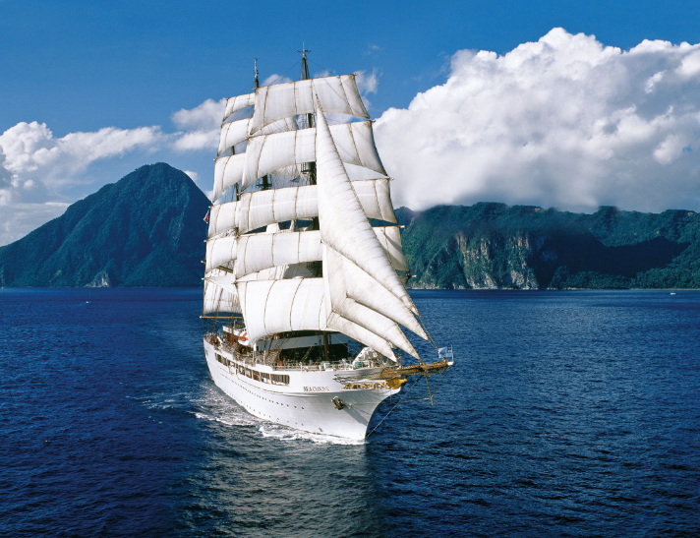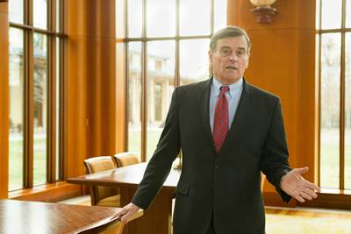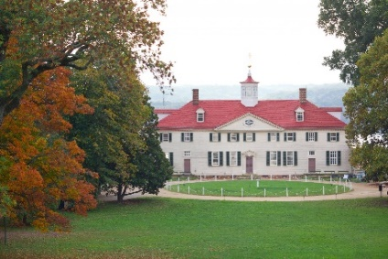

Image Link

Hollywood, Fla (March 21, 2024) – Sea Cloud Cruises, one of the world's most storied names in cruise travel announces a special 2025 sailing with George Washington’s Mount Vernon on Sea Cloud II. Director of Executive Leadership Programs at the George Washington Leadership Institute Rear Admiral Peter Cressy will host the Barbados to St. Maarten Feb. 18-25 sailing on Sea Cloud II in 2025. Dr. Cressy, who served in the U.S. Navy, including the Caribbean during the Cold War, will lead discussions on history and leadership including George Washington’s only international travels, to the Lesser Antilles and Barbados.

“History and perseverance permeate throughout the Sea Cloud Cruises fleet and collaborations with aligned institutions like Mount Vernon further elevate our authentic sailing experience,” shares Mirell Reyes, president of Sea Cloud Cruises North America. “Tying together Dr. Cressy’s leadership and knowledge along with tales of President Washington including his travels to Barbados promise to make this sailing a remarkable journey.”

The 7-night voyage through the Lesser Antilles and Grenadines itinerary is the following: Bridgetown/Barbados, Port Elizabeth/Bequia, Chatham Bay/Union Island, Soufriere/St. Lucia, Cabrits/Dominica, day under full sails, Gustavia/St. Barthélemy and ending in Phillipsburg/St. Maarten.

“President Washington sailed the Caribbean with his older brother and drafted a detailed diary of his only explorations outside what would be become the United State of America,” explains Director of Executive Leadership Programs at the George Washington Leadership Institute Peter Cressy, Ed.D., RADM (Ret.) “Speaking on board the Sea Cloud II will bring this history to life in an unrivaled setting and create lasting memories for all.”

Guests onboard this special George Washington’s Mount Vernon and George Washington Leadership Institute sailing can expect engaging conversations on history and leadership. Dr. Cressy will also present his lecture entitled “Washington, Lincoln, Roosevelt, Churchill: A Strategic Approach to Leading in Times of Crisis.” In this presentation, Cressy will draw insightful parallels between the four iconic leaders and their strategic approaches to crisis management. Also, a longtime leader of the Distilled Spirits Council, Cressy will lead a tasting of Mount Vernon’s own rum from the estate distillery.

Dr. Peter Cressy has been the Director of Executive Leadership Programs at the George Washington Leadership Institute for the past eight years. He served 28 years in the United States Navy in command and senior staff positions, followed by eight years in higher education as a college president and university chancellor, where he was also a tenured professor of management. He later served 16 years as the President and CEO of the Distilled Spirits Council trade association. Dr. Cressy has taught graduate and undergraduate classes at several universities and colleges.

Sea Cloud Cruises sailings offer a well-balanced mix of authentic sailing experiences and unique discoveries ashore. With paramount courteousness and consideration, the crew creates a
wonderfully relaxed atmosphere combined with impeccable service.

For more information on Sea Cloud Cruises, contact your travel advisor, call 1-888-732-2568, e-mail reservations@seacloud.com or visit www.seacloud.com.

About the George Washington Leadership Institute
The Mount Vernon Ladies’ Association founded the George Washington Leadership Institute in 2013 to examine and teach about the leadership qualities of America’s first president. Learning from failure and mentorship, George Washington became one of the premier leaders of the young United States.

His commitment to execution, focus on strategic vision, and emphasis on organizational character are still important lessons for 21st century leaders to learn from and reflect on.

About Sea Cloud Cruises
Since 1979, Sea Cloud Cruises has been one of the world's most storied names in cruise travel. The 90-year-old four-masted Sea Cloud, her younger sister Sea Cloud II, and new Sea Cloud Spirit combine the experience of traditional seamanship with the ambience and luxurious charm of classically elegant private yachts. Berlitz Cruise Guide regularly ranks Sea Cloud and Sea Cloud II among the top five cruise ships in the world. For more information, visit www.seacloud.com.

Media Contact:
Michael Hicks
786-261-1448
Michael.hickspr@gmail.com

