SEA CLOUD CRUISES UNFURLS 2024 SAVINGS WITH “SAIL THE WAVE”
Limited-Time Offer Fleetwide

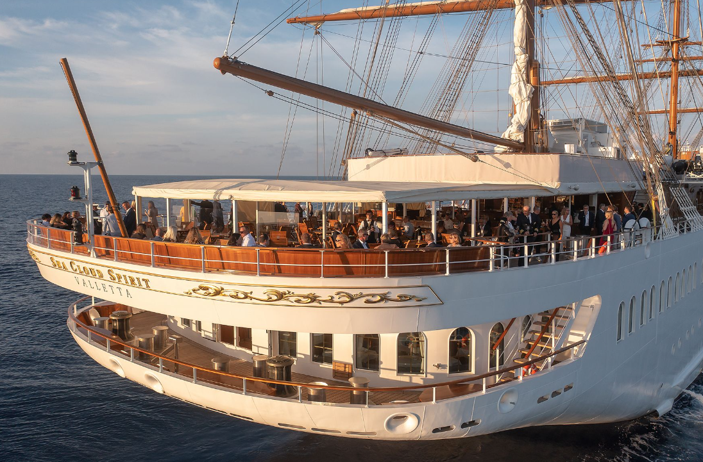
Media Images Link

Ft. Lauderdale, Fla (January 2, 2024) – Sea Cloud Cruises, one of the world's most storied names in cruise travel, announces its largest Wave Season offer in company history. The Sail the Wave promotion is now available on over 100 voyages during the 2024 and 2025 seasons. Travelers can enjoy 25% savings and $500 onboard credits on Sea Cloud Spirit, the newest and largest ship in the fleet. One-level stateroom category upgrades are available on eligible sailings aboard the iconic Sea Cloud II and original Sea Cloud. For these Sail the Wave savings, bookings must be made before February 29, 2024.

“North American travelers and travel advisors continue to discover Sea Cloud Cruises authentic tall-ship experiences,” shares Sea Cloud Cruises President Mirell Reyes. “Our new Sail the Wave promotion provides enticing incentives to book a voyage soon and we look forward to welcoming more new guests onboard for the 2024 and 2025 seasons.”

On each of the three sailing yachts, the sails are still traditionally hoisted by hand – an impressive and stunning job every time. There are no buttons that can simply be pressed and it takes almost a full hour until all sails catch the wind. Each voyage includes at least one day under full sail, a highlight of the Sea Cloud Cruises experience.

Upcoming Sail the Wave Sea Cloud Spirit voyages for 2024 include the following:

Panama City (Colon)/Panama to Nassau (16 nights): Bocas del Toro/Panama, Puerto Limon/ Costa Rica, day beneath full sails, Isla de Providencia/Colombia, day beneath full sails, Isla de Providencia/Colombia, day beneath full sails, Guanaja/Honduras, Belize City/Belize, Lighthouse Reef/Belize, day beneath full sails, Cozumel/Mexico, day beneath full sails, Progreso/Mexico, four days under full sail and Nassau/Bahamas. Feb. 16-March 4, 2024

Las Palmas/Gran Canaria roundtrip (10 nights): Los Cristianos/Tenerife, San Sebastian/La Gomera, Santa Cruz/La Palma, day at sea, Funchal/Madeira and overnight, day beneath full sails, Arrecife/Lanzarote and overnight. March 25- April 4, 2024
Edinburgh to Hamburg (8 nights): Edinburgh (Leith)/ Great Britain, Aberdeen/Great Britain, day under full sails, Stavanger/Norway, day under full sails, List/Sylt overnight, day under full sails, Hamburg.) June 27-July 5, 2024

Upcoming Sail the Wave Sea Cloud II voyages for in 2024 include:

Malta to Athens (9 nights): Valletta/Malta, Syracuse/Sicily, day under full sails, Fiscardo/Greece, day under full sails, Monemvasia/Greece, Nauplio/Greece, Syros/Greece, Athens (Piraeus) July 1-10

Upcoming Sail the Wave Sea Cloud voyages for in 2024 include:

St. Maarten roundtrip (7 nights): North Sound/ Virgin Gorda, Norman Island/British Virgin islands, day under full sails, Terre-de-Haut/Iles des Saintes, Cabrits/Dominica, Gustavia/St Barthelemy. Dec. 13-20

Sea Cloud Cruises voyages include open bar, all meals with exclusive wine and beer selections, water sports, port charges, gratuities and welcome bottle of champagne upon embarkation. Fares per person, based on double occupancy from $1,995. For a full list of Sail the Wave voyages, visit link. For more information on Sea Cloud Cruises, contact your travel advisor, call 1-888-732-2568, e-mail reservations@seacloud.com or visit www.seacloud.com.

About Sea Cloud Cruises
Since 1979, Sea Cloud Cruises has been one of the world's most storied names in cruise travel. The 90-year-old four-masted Sea Cloud, her younger sister Sea Cloud II, and new Sea Cloud Spirit combine the experience of traditional seamanship with the ambience and luxurious charm of classically elegant private yachts. Berlitz Cruise Guide regularly ranks Sea Cloud and Sea Cloud II among the top five cruise ships in the world. For more information, visit www.seacloud.com.

Media Contact:
Michael Hicks
786-261-1448
Michael.hickspr@gmail.com

