SEA CLOUD CRUISES SETS SAIL FOR NORTH AMERICA GROWTH:
ANNOUNCES NEW PRESIDENT MIRELL REYES AND VICE PRESIDENT SALES KEVIN SMITH

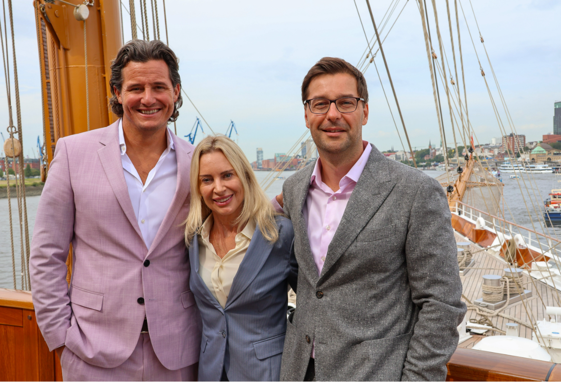
L-R: Kevin Smith, Mirell Reyes, Daniel Schaefer

Media Images Link

Hamburg, Germany (August 22, 2023) – Sea Cloud Cruises, one of the world's most storied names in cruise travel, is adding senior leadership in North America dedicated to growing the market. The company announced today that Mirell Reyes has been appointed to Sea Cloud Cruises’ executive team as president, overseeing all sales, marketing, and communications in North America. Joining her is Kevin Smith as vice president of sales, focused on consortia, travel advisors, groups, and new charter partnerships for the brand. Sea Cloud Cruises US will operate out of South Florida.

“The Sea Cloud experience is one steeped in history, sustainability and luxurious European service, which resonates with today’s traveler,” said Sea Cloud Cruises US CEO Daniel Schaefer. “Mirell’s and Kevin’s vast cruise knowledge and background in the luxury high-end market combined with their strong industry relationships, will play a major role in growing the Americas.”

For over 20 years Reyes has built a career in travel and hospitality, most recently as president of Star Clippers Americas where she also held the role of vice president of sales for the German speaking markets. Her extensive career includes serving as executive director of sales and marketing for TUI Leisure Travel, with suppliers including Hapag-Lloyd Cruises, Cunard Line and Holland America offering tailor-made voyages to high-net-worth individuals.

“I am honored to take on the role of bringing and elevating the storied Sea Cloud brand to North America, introducing our iconic Sea Cloud, Sea Cloud II and newest ship Sea Cloud Spirit to an audience of discerning travelers seeking a truly unique and luxury sailing journey,” shared Sea Cloud Cruises president Mirell Reyes.

Kevin Smith brings over 15 years of experience to Sea Cloud Cruises, most recently leading sales efforts for American Queen Voyages as vice president of sales. His career also includes sales positions with luxury cruise brands including AmaWaterways River Cruises and Silversea Cruises.

“The legendary Sea Cloud Cruises fleet and service level is truly unmatched, and I look forward to building strong partnerships with our trade community to create memorable experiences for their well-traveled guests,” said Kevin Smith, vice president sales for Sea Cloud Cruises.

For more information on Sea Cloud Cruises, contact your travel advisor, call 1-888-732-2568 or visit www.seacloud.com.

About Sea Cloud Cruises
Since 1979, Sea Cloud Cruises has been one of the world's most storied names in cruise travel. The 90-year-old four-masted Sea Cloud, her younger sister Sea Cloud II, and new Sea Cloud Spirit combine the experience of traditional seamanship with the ambience and luxurious charm of classically elegant private yachts. Berlitz Cruise Guide regularly ranks Sea Cloud and Sea Cloud II among the top five cruise ships in the world. For more information, visit www.seacloud.com.

Media Contact:
Michael Hicks
786-261-1448
Michael.hickspr@gmail.com

