SEA CLOUD CRUISES UNFURLS 2024 SEASON IN NEW COMPREHENSIVE BROCHURE
“AUTHENTIC SAILING JOURNEYS”
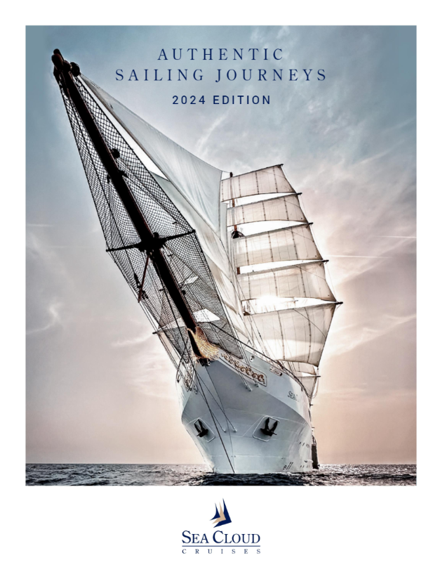
Media Images Link

Ft. Lauderdale, Fla (December 4, 2023) – Sea Cloud Cruises, one of the world's most storied names in cruising, has released its 2024 Authentic Sailing Journeys brochure, featuring 95 pages of stunning photography and elegantly describing the upcoming season. The catalog highlights the experience onboard the luxurious tall ships as they sail 4 to 16-day voyages, following less traveled routes and calling on boutique ports.

The 2024 collection for the 90-year-old four-mast Sea Cloud, and her younger sisters Sea Cloud II and Sea Cloud Spirit features 80 voyages redefining cruising sustainably with over 160 days under full sail. A lineup of Special Occasion voyages including the St. Barths Bucket Regatta, the Monaco Historic Grand Prix and America’s Cup, encompass marquee moments for the 2024 season. Many sailings will be hosted by Michelin-starred chefs, feature bespoke musical experiences or renowned lecturers onboard.

“The Sea Cloud Cruises fleet will ring in the New Year in Cartagena, Bequia and Virgin Gorda, with a special 2024 season in store, charting courses away from the crowds, “shares Mirell Reyes, president of Sea Cloud Cruises. “We encourage North American travelers and advisors to download or request our Authentic Sailing Journeys brochure and our crew looks forward to welcoming many onboard in 2024.”

Below is an overview of the 2024 season profiled in the Sea Cloud Cruises Authentic Sails Journeys brochure:

Sea Cloud Spirit

Sea Cloud Spirit, Sea Cloud Cruises largest and most-modern tall ship, sets sail with immersive voyages through Central America exploring Costa Rica, Panama, Belize, Honduras and Mexico’s Yucatan Peninsula. After making her way to Florida and The Bahamas in March, Sea Cloud Spirit will embark on her spring season with the Canaries, followed by Morocco and Spain. For the summer 2024, Sea Cloud Spirit delivers unique Atlantic Coast and Northern Europe itineraries under sail. She will travel to Lisbon, Bilbao including a VIP evening tour of the Guggenheim, Bordeaux, England, Ireland, and Norway, before sailing the emerald Azores and returning to the Caribbean.

Sea Cloud II

Sea Cloud II sails the Caribbean January through April homeporting in St Maarten and Barbados. She visits favorite sailor ports including Martinique, Isles de Santes and Santa Domingo before embarking on her European season beginning from Lisbon to Barcelona in April. Guests on the sailing embarking May 8 will take in the Hollywood glamour of the Monaco Historic Grand Prix with VIP access. Sea Cloud II will then sail Capri, Sardina and Corsica, Sicily, Greece, French and Italian Rivieras during her summer 2024 season. She makes her 17-day full sail crossing beginning Nov. 25 from the Canary Islands to Guadeloupe, where her Caribbean season begins.

Sea Cloud

Sea Cloud will elegantly sail the Caribbean homeporting in St Maarten and Barbados for much of the winter season calling on intimate ports including Anguilla, Nevis, Mayreau and Bequia. Guests sailing in the footsteps of original Sea Cloud owner Marjorie Merriweather Post will have a front row seat to the St. Barths Bucket Regatta. Sea Cloud II will mirror this Special Occasion sailing delivering a unique experience for sailors as the two tall ships sail side-by-side. Her Caribbean season will conclude with a second rendezvous alongside Sea Cloud II sailing the British Virgin Islands, Lesser Antilles and returning to St. Maarten.

Limited availability remains on Sea Cloud once again as she sails the Aegean and lesser-visited Greek Isles of the Cyclades and Dodecanese. Following this itinerary is an Athens to Venice voyage with a stunning conclusion sailing through the heart of Venice and its famed Grand Canal. She will sail the coast of Croatia, circumnavigate Sicily and the Mediterranean Islands of Corsica and Sardina before making her way to the Canary Islands for the Atlantic crossing.

Onboard Credit Now
Now through December 31, Sea Cloud Cruises is offering a $250 onboard credit per person on all bookings. Sea Cloud Cruises fares per person, based on double occupancy are from $3,655. For more information, contact your travel advisor, call 1-888-732-2568, e-mail reservations@seacloud.com or visit www.seacloud.com.

About Sea Cloud Cruises
Since 1979, Sea Cloud Cruises has been one of the world's most storied names in cruise travel. The 90-year-old four-masted Sea Cloud, her younger sister Sea Cloud II, and new Sea Cloud Spirit combine the experience of traditional seamanship with the ambience and luxurious charm of classically elegant private yachts. Berlitz Cruise Guide regularly ranks Sea Cloud and Sea Cloud II among the top five cruise ships in the world. For more information, visit www.seacloud.com.

Media Contact:
Michael Hicks
786-261-1448
Michael.hickspr@gmail.com

