**Michelin Star Chef Michael Collantes and Sommelier Benjamin Coutts to join *Sea Cloud Spirit* for**

**Fall 2024 Mediterranean Voyage**

** 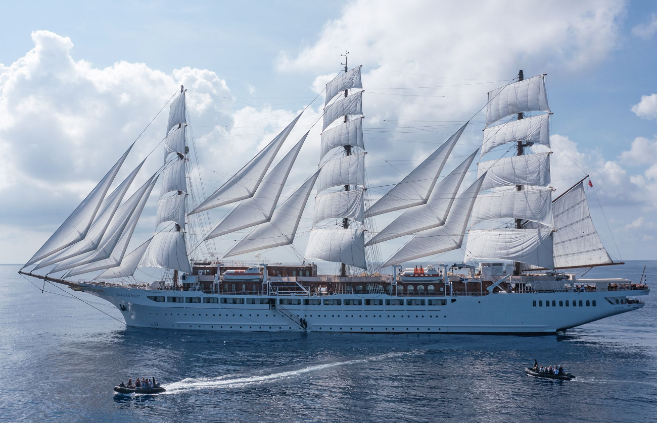****

[**Image Link**](https://www.dropbox.com/scl/fo/jgwrskmxdtqk055hy1atf/h?rlkey=sn5dtc4g27fhau6s57i6ge0cj&dl=0)

**Hollywood, Fla (February 8, 2024) –** [Sea Cloud Cruises](https://www.seacloud.com/en/), one of the world's most storied names in cruise travel announces Chef Michael Collantes will serve as a guest chef onboard *Sea Cloud Spirit***.** Collantes is the Head Chef and Owner of **[Soseki](http://www.sosekifl.com/" \t "_blank)**, a one Michelin star modern omakase restaurant located in his hometown of Winter Park, Fla. He is also chef/owner of [Sushi Saint](https://www.sushisaint.com/), Central Florida’s first handroll bar experience, soon opening a New York outpost. Collantes will share his skilled culinary craft and storytelling on the fleet’s newest and largest sailing yacht [Nice to Barcelona Oct. 5-12, 2024](https://www.seacloud.com/en/cruises/from-the-cote-d-azur-to-corsica-and-spain-scs-2438/)

“Sea Cloud Cruises has a tradition of innovative collaborations with Michelin star chefs and our onboard culinary team is counting the days to welcome Chef Collantes,” shares Mirell Reyes, president of Sea Cloud Cruises. “Chef Michael’s charisma as he creates artistic interpretations using fresh ingredients from the region’s local markets will be a delectable treat for everyone.”

The 7-night voyage exploring boutique ports of the Mediterranean is the following: Nice/Frances, day under full sails, Calvi/Corsica, Bastia/Corsica, Sanremo/Italy, Marseille/France, Palamos/Spain and Barcelona/Spain. The voyage will feature no more than 136 guests onboard and include lively cooking demonstrations, curated menus and storytelling underneath the *Sea Cloud Spirit’s* 28 hand-hoisted sails.

“I was attracted to the *Sea Cloud Spirit* immediately, knowing I would have the opportunity to source sustainable fish and produce directly from local purveyors in the morning and prepare that evening onboard the sailing yacht,” shared Collantes. “This central Mediterranean region offers a bounty of delicacies and we look forward to being a part of this evolving lifestyle brand.”

Michael Collantes is a Filipino-American chef and an Orlando native who is driven by the local ingredients of Central Florida and influenced by his impressive repertoire of culinary experiences. Throughout his decades-long career, he has worked under the tutelage of some of the country’s most celebrated chefs, including Wolfgang Puck, Joel Robuchon, Eric Ripert, Masa Takayama, and Jen Carroll.

In addition to his Central Florida restaurants Soseki and Sushi Saint, Collantes also serves as the Culinary Director for the MM Members Club at Ava Winter Park and Mila Miami and is a Chef Ambassador for the Edible Education Experience.

Sommelier Benjamin Coutts is a celebrated figure in the wine and hospitality industry, known for his ability to create unforgettable experiences for his guests. In 2023 Benjamin was awarded Florida's "Sommelier of the Year" by the Michelin Guide. His continued success is a testament to his talent, passion, and dedication to his craft.

Coutts was part of the opening team at Soseki Modern Omakase, with over 25 years of experience in beverage and hospitality. His contribution and dedication helped Soseki earn their first Michelin star in 2022. He draws from his studies with The Court Masters of Sommeliers, and Wine & Spirit Education Trust (WSET), along with his leadership roles at Augustan Wine Imports, Progress Wine Group, and Team Management Group.

On each of the three sailing yachts, the sails are still traditionally hoisted by hand – an impressive and stunning job every time. There are no buttons that can simply be pressed and it takes almost a full hour until all sails catch the wind. Each voyage includes at least one day under full sail, a highlight of the Sea Cloud Cruises experience.

Sea Cloud Cruises sailings offer a well-balanced mix of authentic sailing experiences and unique discoveries ashore. With paramount courteousness and consideration, the crew creates a

wonderfully relaxed atmosphere combined with impeccable service.

For more information on Sea Cloud Cruises, contact your travel advisor, call 1-888-732-2568, e-mail [reservations@seacloud.com](mailto:reservations@seacloud.com) or visit [www.seacloud.com](http://www.seacloud.com).

**About Sea Cloud Cruises**

Since 1979, Sea Cloud Cruises has been one of the world's most storied names in cruise travel. The 90-year-old four-masted *Sea Cloud*, her younger sister *Sea Cloud II*, and new *Sea Cloud Spirit* combine the experience of traditional seamanship with the ambience and luxurious charm of classically elegant private yachts. Berlitz Cruise Guide regularly ranks *Sea Cloud* and *Sea Cloud II* among the top five cruise ships in the world. For more information, visit [www.seacloud.com](http://www.seacloud.com).

Media Contact:

Michael Hicks

786-261-1448

[Michael.hickspr@gmail.com](mailto:Michael.hickspr@gmail.com)